Signage suggestions for Trainers/breeders
Introduction
Safety signs draw attention to objects and situations affecting health and safety and explanations of their functions and meanings should be included in induction programs. They do not replace the need for systems or measures to control the particular hazard and can generally be grouped in the following categories:
(a) Regulatory signs: containing instructions, which if not complied with constitute an offence at law or a breach of standing safety procedures, e.g. fire, naked flame and smoking prohibited; head protection must be worn; hearing protection must be worn; drive between yellow lines only.
(b) Hazard signs: warning of hazards such as fire risk, explosion risk, toxic hazard, forklift hazard, electrical shock hazard.
(c) Emergency information signs: indicating the location of facilities such as emergency exits, safety equipment, first aid facilities.
(d) Fire signs: advising the location of fire alarms and fire-fighting facilities.
There is a Standard that provides detailed guidance on the design of different types of signs, and how and where they should be displayed. The Standard recommends that explanation of the functions and meanings of safety signs should be included in employee training and induction programmes. When a new sign is displayed, or the location of an existing sign changed, employees should be informed of this, and the reasons for the change explained. Safety equipment suppliers provide a range of safety signs that comply with the Standard.
The stable must erect signs in any area where there is a potential risk to health and safety. Signage should warn stakeholders/patrons/visitors/workers of the danger within the specified area and, where necessary, exclude nominated people from entry to these areas.
The key areas that must be covered, but not limited to are:
- entry gates;
- float drop off;
- stable and tie up stalls;
- horse barns;
- horse exercise yards;
- connecting walkways;
- machinery and equipment sheds;
- storage sheds (hazardous substances);
- building/venue evacuation procedures.
Signage should also be erected at the entrance gates to the complex, particularly where the course attracts a lot of traffic. These signs should warn people that they are entering a horse containment area and be aware of horses and riders at all times and advise all visitors/contractors to report to the office (if appropriate).
Other examples of when you need signs
Signs are needed when you store chemicals and fuels above certain amounts. However, it is recommended that appropriate signs are put in place when storing hazardous substances not matter what the volume or amount. Some common hazardous substances are:
- toxic pesticides, such as paraquat and Counter
- ecotoxic products, such as diazinon
- oxidising fertiliser, such as calcium nitrate
- Petrol/diesel/kerosene in drums, containers or bulk tanks

Where to put signs
Signs must be displayed in all storage area entrances, including vehicle access points, and should be at eye level. They must be close to the storage area but not so close that people come across hazardous substances before being warned. If your storage area is in a room inside a building, display signs at the building entrance and at the entrance to the room. If chemicals and fuels are stored in an outdoor area, signs must be displayed immediately next to the storage area.
What to put on signs.
Signs must be big enough so they can be read from 10 metres away. Signs must tell people, in plain English or pictograms:
- that the storage area contains hazardous substances;
- the hazards of each product in the store;
- the precautions needed to manage them safely;
- what to do and who to contact in an emergency.
Remember to source your signs from a certified safety supply company so they comply with NZ Standards, some examples below.

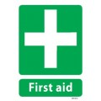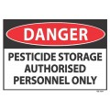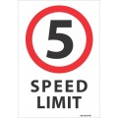

Examples of specific stable and racetrack signs
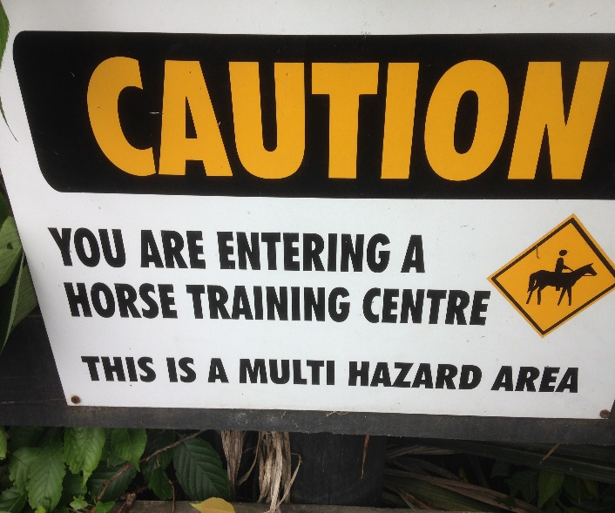
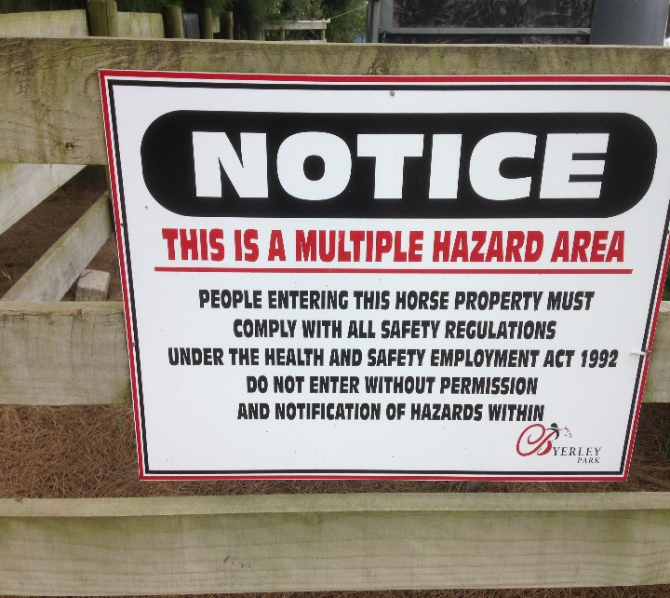
NOTE – Update Employment Act 1992 to Health and Safety at Work Act 2016

All racecourses and stables or breeding establishments that have high visitor or contractor traffic should have signs on their main entrances to make sure that all visitors are aware they are in a controlled area and must report in.

Here is an example from Addington raceway.
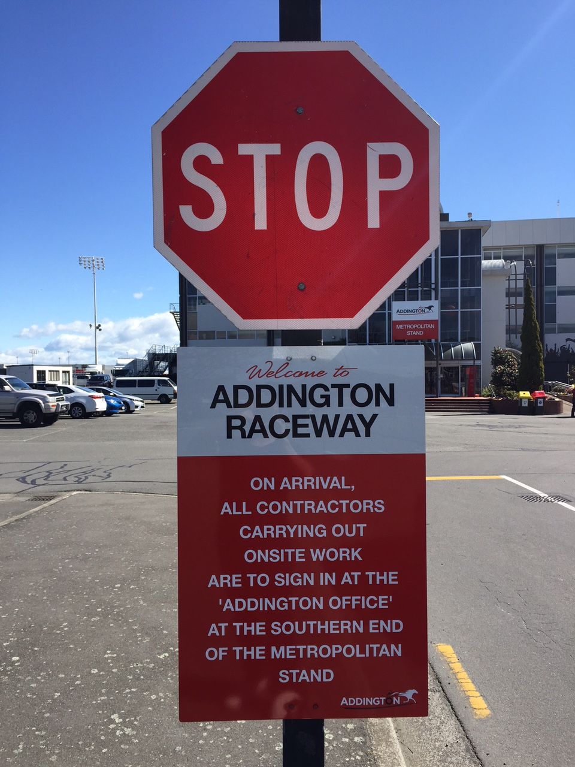

It is recommended that your club conducts a full audit of all current signage to check the signs that are in place are suitable for the area/conditions/hazard they are highlighting and identify areas that require signage that currently don’t have signs in place.
There are many companies supplying safety signs that comply with the NZ Standards, some examples are:
http://safetysign.co.nz/
http://www.segno.co.nz/
http://www.activesafety.co.nz/nz-safety-shop/safety-signs
http://www.nzsafetycatalogue.co.nz/

