DISCLOSURE STATEMENT
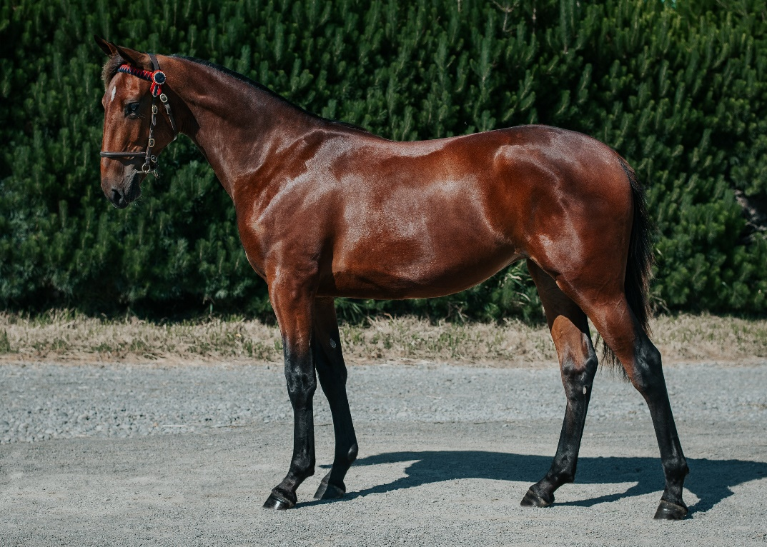
This is a Disclosure Statement for an offer of shares in a syndicate which will purchase the hose/s described below for the purposes of participating in races.
SYNDICATOR NAME
Sire x Dam
Year of Foaling
Sex

- About the Syndicate

[Name of trainer] is offering shares in [] [describe horse eg a yearling colt by [name of sire] from [name of mare] which was purchased at the New Zealand Bloodstock Karaka 2022 Yearling sales].
A share in this horse offers the opportunity to experience all the excitement and thrills of owning a racehorse at a fraction of the cost. As a shareholder in the horse, you will get lots of information including regular updates on how the horse is progressing. You will also be entitled to all the on-course benefits of a racehorse owner.
Shares will be sold in 5% divisions, but you are welcome to buy more than one share. Alternatively, you may get a few of your friends or relatives together to buy a share.
The monthly costs of keeping the horse will be shared by the shareholders in proportion to their ownership shares. An initial payment towards the costs of buying the horse will secure your share and then you will be sent an invoice each month for your share of monthly costs. The monthly cost will vary, depending on a number of things, for example, how often the horse races, if it needs veterinary treatment, if it needs shoes, etc. An indication of what these costs may be is shown below.
All prizemoney will be shared by the shareholders in proportion to their ownership shares. Any money earned by the horse will be offset against the expenses, with the balance being allocated to shareholders.
The horse will be trained in New Zealand, but if the horse is good enough, it could race in Australia.
The syndicate will be governed by the Syndicate Agreement.
When the time comes, a decision will have to be made about the horse’s future after its racing career is over. The decision will depend on how good the horse was as a racehorse, if it was very good it may be a breeding prospect. If not, it may have to be retrained for another career, perhaps as a riding horse or a sport horse.
A thoroughbred’s career can continue in a new discipline after their time in racing. For young horses who just haven’t quite made the grade, other options include racing in another district with another trainer or transferring the horse to another trainer locally. If the horse is retired, we will find a new home and potentially a new career for it.

- Upfront Costs

Purchase Price (including GST)
Auction Sale
Date of Sale
  - Purchase Price.

  - Other initial costs.

Buyer agent fee
Commission
Marketing and promotion
Valuation
Vet Report
Transport
Training fees
Other (specify)

  - Number of Shares to be issued

Number of shares

  - Cost per share

Cost per 5% share | NZ$

- Estimated On-going Costs and Expenses (All costs are inclusive of GST)
The following costs and expenses are estimates only and are provided solely to give potential applicants an indication of likely costs and expenses. They do not purport to cover all costs that may be incurred.

Training Fees | $95/day
Track fees | $135/month
Agistment fees when spelling | $30/day
Jumpouts | $50
Transport | At cost
Farrier | $230
Dentist | $80
Veterinarian | At cost
Supplements | At cost
Vaccination | $300/year
Nomination Fees | No nomination/acceptance fees if horse starts unless it’s a black type race
Jockey fee | $150/race

- Insurance Information

Insurer
Term
Insured Value
Type of cover

- Valuation Reports (not required if the horse is to be leased by the syndicate or if the horse was purchased at a public auction sale)

The horse being syndicated has been independently valued by two registered Valuers.

Registered Valuer Name | Horse value | Date of Valuation

The valuation reports are not attached. A copy of the valuation reports may be obtained on request or by requesting copies from NZ Thoroughbred Racing (syndication@nzracing.co.nz).
- Veterinary Report
A vet has examined the horse and has certified that it is sound for racing.

Name of Vet | Date of certificate

A copy of the veterinary report may be obtained on request or by requesting a copy from NZ Thoroughbred Racing (syndication@nzracing.co.nz).
- Material interests and Commissions.

  - Disclosures of any material or pecuniary interests

[Note: Any material or pecuniary interest that the Syndicator or any person associated with the Syndicator has in the horse (or any of its close relatives) , and any material relationship that the Syndicator has with the vendor of the horse, must be disclosed in this Disclosure Statement. For example, if the horse had been sold by the Syndicator, or by any of their Associated Persons, within 12 months prior to the Offer, the purchaser, price paid and date of the transaction within that period must be disclosed]
  - Confirmation of Disclosure of Commissions etc.

The nature and amount of all commissions, fees or rebates and other benefits that have been or may be received in the future by the Syndicator (or an Associated Person of the Syndicator), specifically in relation to the horse of the syndicate have been fully disclosed in sections 4 and 5 of this Disclosure Statement. Any such commissions, fees, rebates, or other benefits that may be received in the future will be disclosed to Shareholders in writing at the time.

- Standard Industry Risks

Racing horses is a lot of fun, there is nothing more exciting than watching your horse run at a racemeeting against the other horses. Although we hope that the horse will turn out to be a star, we should have realistic expectations. We do need to understand that:

  - Not all yearlings/prospective racehorses proceed to become racehorses.

  - There is a significant possibility that any racehorse could injure itself and thereby need a long recuperation period or be unable to race again.

  - Racehorses are unlikely to have any significant value at the end of their racing career with the exception of well-bred and/or highly performed horses which are suitable to become breeding stock.

- Governing Documents.

The Syndicate will be governed by the attached Syndicate Agreement. Applicants should read this Disclosure Document and the Syndicate Agreement carefully and request legal advice, if necessary, before applying for shares in the horse

- Declaration and Agreement.

[Name of Trainer]:

  - is an Authorised Syndicator under a Code of Practice administered by New Zealand Thoroughbred Racing Inc. New Zealand Thoroughbred Racing Inc. does not endorse nor does it guarantee the success or otherwise of the offer made under this Disclosure Statement and accepts no responsibility whatsoever for any statements or representations made in this Disclosure Statement or for any loss or liability arising from participation in the offer; and

  - agrees to observe and comply with this Disclosure Statement and the Syndicate Agreement.

This Disclosure Statement and all related documentation may be inspected at the premises of New Zealand Thoroughbred Racing (106-110 Jackson Street, Petone) or a copy may be requested by writing to PO Box 38 386, Wellington Mail Centre or by emailing syndication@nzracing.co.nz.

……………………ooOoo…………………….

Applicant Acknowledgement of Receipt, Understanding and Agreement

I, the undersigned Applicant, agree to become a shareholder of Syndicate Name and, subject to the acceptance of my application:
- Acknowledge receipt of the Disclosure Statement together with the accompanying Syndicate Agreement, and

- Confirm that the Disclosure Statement and the Syndicate Agreement have been read and understood by me; and

- Agree to be bound by the terms set out in the Disclosure Statement and the Syndicate Agreement; and

- Grant the powers and authorities given to the Syndicator and the Syndicate Manager under the Disclosure Statement and the Syndicate Agreement; and

- Declare that I am at least 18 years of age and am not, by the provisions of the Rules of Racing, prohibited from owning a racehorse and that I am not otherwise prohibited from admission to a racecourse.

I wish to apply for ________ % share in the Syndicate Name and agree to pay the sum of $________________ as the GST inclusive purchase price of that share.

Name |  |  | Surname
Date of Birth
Address
 |  |  | Post Code
Mobile |  |  | Phone
Email
Bank Account Number

Signature of Applicant |  |  |  | Date

